Descriptive Analysis of Persisting Effects of the Berlin Division on Airbnb Markets

Authors: Aayush Dhakal, Nicolás Pazos, Sharanya Bhattacharjee, and Melissa Carson
ACE 592, 2025

Background
Following the end of the Second World War in 1945, Germany was divided into two separate states. The western portion of the country became the Federal Republic of Germany (FRG) under the influence and administration of the United States, the United Kingdom, and France, while the eastern portion, known as the German Democratic Republic (GDR), was placed under Soviet control. The capital city of Berlin, although located entirely within the territory of the GDR, was similarly partitioned among the four Allied powers, resulting in a divided city emblematic of the emerging Cold War tensions.
By 1961, significant numbers of East Germans—approximately 20% of the GDR's population—had migrated to West Germany, seeking political freedom and economic opportunity. In response, the East German government, with Soviet backing, constructed the Berlin Wall in August 1961 to physically and ideologically separate East Berlin from West Berlin and prevent more migration west. The Wall quickly became a symbol of the Cold War, often referred to as the Iron Curtain.
The Berlin Wall fell on November 9, 1989, signaling a changing tide in geopolitics. Nevertheless, the consequences of this division—and the transition from a centrally planned economy to a market-based system—were neither immediate nor uniform. Economic disparities, social tensions, and political challenges persisted in the post-reunification period, underscoring the complex and uneven nature of this historic transformation (Jarausch, 2010). Many researchers have investigated this phenomenon across multiple dimensions , generally finding there is a persisting effect of the Berlin division on household income, wealth, and other sociodemographics in Germany (Ahfeldt et al (2015); Burchardi and Hassan (2011); Kottasova and Croker (2019))
We ask, are there persisting effects of the Berlin Division on Airbnb markets? We hypothesize that tourists, those renting Airbnbs, who choose a location near the Berlin division, are locating there to see the site of the Berlin division. Thus, perhaps tourists should be marginally indifferent between an Airbnb in East or West Berlin. Implying there should be minimal persistent effects in the Airbnb market that are not already explained by longer differing household-level trends between East and West Berlin. Further, Airbnb is just over a decade old. To look into this we can compare East and West Berlin characteristics to descriptively indicate persistence effects. Asking, are there Persistent Effects of the Berlin Division in the Airbnb market?

Data
We use publicly available data from Inside Airbnb, an independent project that provides insights into the short-term rental market. While the platform offers rich data for research, it is important to acknowledge that Inside Airbnb is a mission-driven and advocacy-oriented initiative. As stated on their website: “Inside Airbnb is a mission driven project that provides data and advocacy about Airbnb's impact on residential communities. We support residents and activists who are organizing to protect their communities from the negative effects of short-term rentals.” Though independent, their mission introduces potential bias in how the data is curated and presented. Additionally, Inside Airbnb collects its data from publicly accessible Airbnb listings, which may not represent the full scope of listings or their dynamic changes over time.
A critical limitation in the dataset is the anonymization of listing locations. Exact geographic coordinates are intentionally obfuscated to protect host privacy. Each listing's location is randomized within a 150-meter radius, and even listings within the same building are separately anonymized. As a result, geographic precision is limited to approximately the city-block level. However, the width of the historical division exceeds 150 meters, meaning that anonymized listings should always fall on the correct side of the East-West divide.
We use the most recent dataset from Inside Airbnb, specifically the December 2024 release. Due to time constraints, and data duplication errors the full 2024 year is not included. This dataset provides detailed information on Airbnb listings, including geographic coordinates, host-provided descriptions, neighborhood overviews, available amenities, nightly prices, guest reviews, and star ratings.
To compare East and West-Berlin Airbnb market characteristics, we perform a series of data cleaning and spatial processing steps. First, we project the latitude and longitude coordinates onto a map of Berlin. Along with a map of the Berlin Wall location, the coordinates allow us to classify each listing as being located in either East or West Berlin. Listings are also assigned to one of Berlin’s 12 boroughs based on their geolocation. Berlin is administratively divided into 12 boroughs: six located in the former West Berlin, four in the former East Berlin, and three that span both sides of the historical divide.
For our descriptive analysis, we focus on attributes relevant to understanding spatial and qualitative differences in listings on either side of the former Berlin Wall. Thus, Figure 1 presents the map of Berlin showing the spatial distribution of Airbnb listings across different boroughs. The east-west division, the historical location of the Berlin Wall, is represented as blue line in Figure 1. The map displays a concentration of Airbnb listings in the central parts of the city, with no apparent clustering differences between the eastern and western sides of the former Berlin Wall. This pattern reflects the proximity of central boroughs to key tourist attractions, which likely drives the higher density of listings in those areas. In total, there are 17,273 Airbnb listings in Berlin in December 2024, of which 54% are in former west Berlin and 46% in the East.

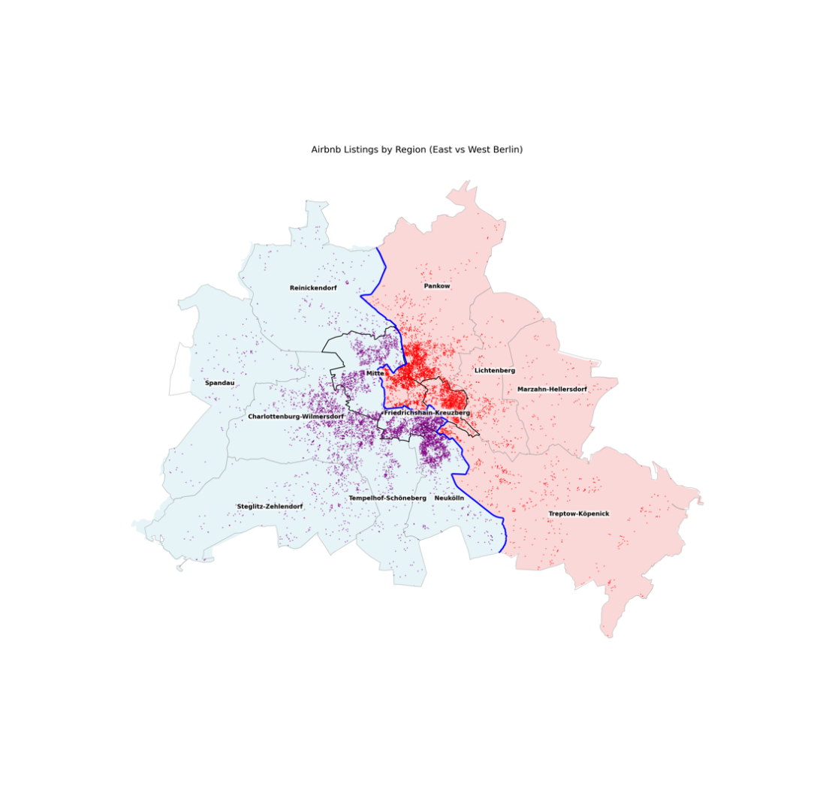
Figure 1. East and West-Berlin Airbnb Locations by Neighborhood
Although the total number of Airbnb listings in East and West Berlin is roughly similar, there is variation in listing counts across individual boroughs. Figure 2 shows a bar chart displaying the number of listings in each borough, categorized by East and West Berlin. Notably, boroughs Mitte, Pankow, and Friedrichshain-Kreuzberg span the former East–West division, so their listing counts are split accordingly. In general, boroughs located closer to the city center tend to have higher concentrations of listings.
Figure 2: Number of Airbnb Listings in Each Borough
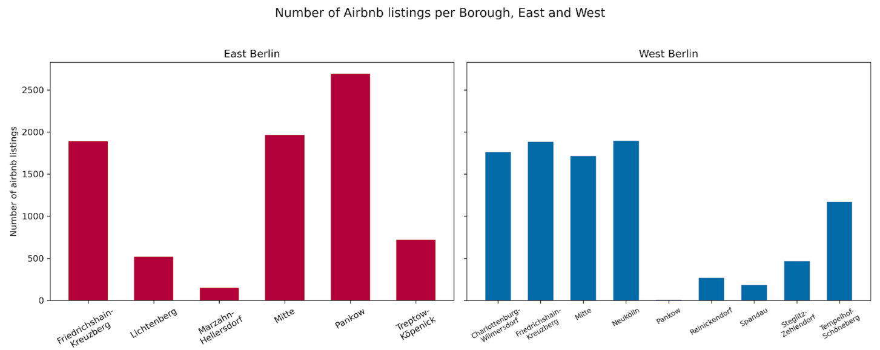

Descriptive Analysis
We select a subset of descriptive variables from the Inside Airbnb dataset to compare listings on either side of the former Berlin Wall. These variables help highlight structural and qualitative differences—or similarities—between Airbnb offerings in East and West Berlin. Characteristics analyzed are: room type, licensing, nightly prices, and star reviews.
Room types: Airbnb listings are categorized into different types based on what is being offered as Airbnb. Hosts can offer entire home/apartment or private room or shared room or hotel room. Figure 3 illustrates the distribution of these room types across East and West Berlin. The composition is notably similar across both regions. The majority of listings in both East and West Berlin are for entire homes or apartments, followed by private rooms. Shared rooms and hotel rooms represent only a small fraction of the total listings. Overall, there are no meaningful differences in room type distribution between the two sides of the former Berlin Wall.
Figure 3: Proportion of Room Types in East and West Berlin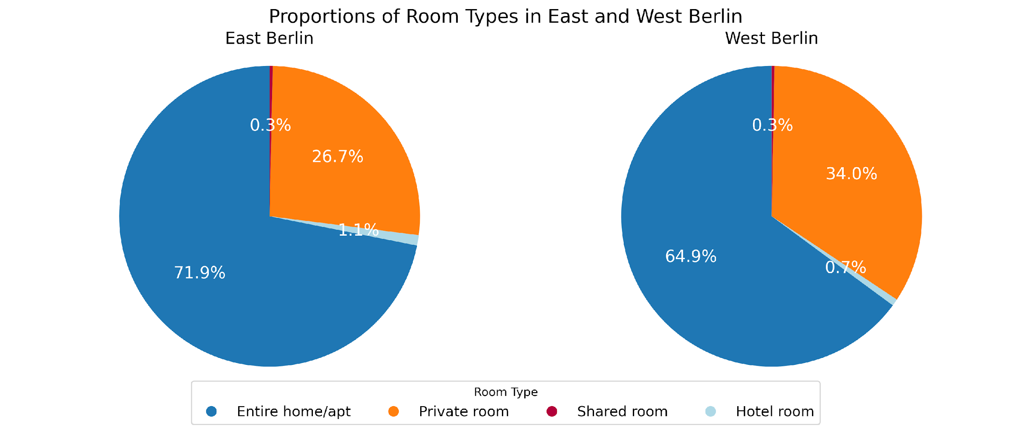

Licensed Vs Unlicensed: The licensure status of Airbnb listings may reflect institutional or regulatory differences across regions. To explore this, we categorize listings based on whether they are officially licensed. Approximately 55% of listings in East Berlin are licensed, compared to around 52% in West Berlin. These proportions suggest that the regulatory compliance of Airbnb hosts is broadly similar on both sides of the former Berlin Wall, reinforcing the general pattern of similarity in listing characteristics across the two regions.
Nightly Prices of Airbnb: We compare the nightly prices of Airbnb listings across the two sides of the former Berlin Wall. Figure 4 presents a map of listing locations, with color intensity indicating price levels—darker shades represent higher nightly rates. Visually, there is no clear distinction in the spatial distribution of prices between East and West Berlin. Even when focusing specifically on listings within a 2-kilometer radius of the central segment of the wall, no sharp contrasts in pricing emerge. Overall, Airbnb prices appear relatively similar on both sides of the wall.
Figure 4: Price of Airbnb in Berlin (left); Price of Airbnb Within 20km of division (right)
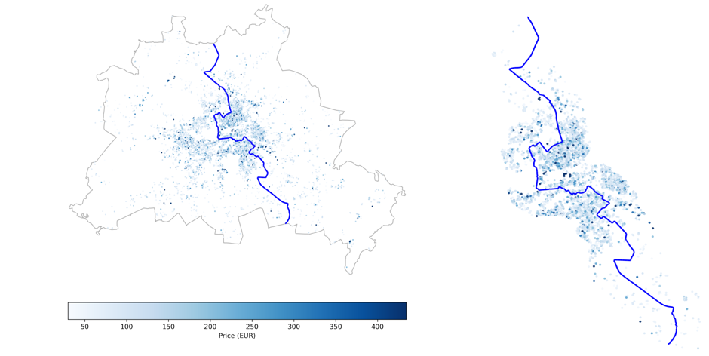
Reviews stars posted by customers: Airbnb guests can leave star ratings for each listing, ranging from zero to five. We investigate whether these review scores differ across the two sides of the former Berlin Wall. The star rating used in our analysis reflects the average score each listing has received over its lifetime. Figure 5 displays a map of Berlin with color intensity representing the average review score—darker shades indicate higher ratings.
In the dataset, very few listings received less than 4.0 stars. As a result, all listings with lower ratings are grouped into a single-color category to emphasize varying scores. This distribution raises concerns about potential data selection bias: if Inside Airbnb disproportionately captures listings with higher ratings, lower-rated listings may be underrepresented or excluded altogether. Such a pattern could obscure any meaningful differences in review distributions across East and West Berlin.
Given this limitation, we find no stark differences in review scores between East and West Berlin. Ratings appear fairly evenly distributed across the city, with no clear clustering of particularly high or low-rated listings. This pattern remains consistent even when focusing only on listings within 2 kilometers of the wall.
Figure 5: Star Review of Airbnbs in Berlin (left); Star Review of Airbnbs Within 20km of division (right)
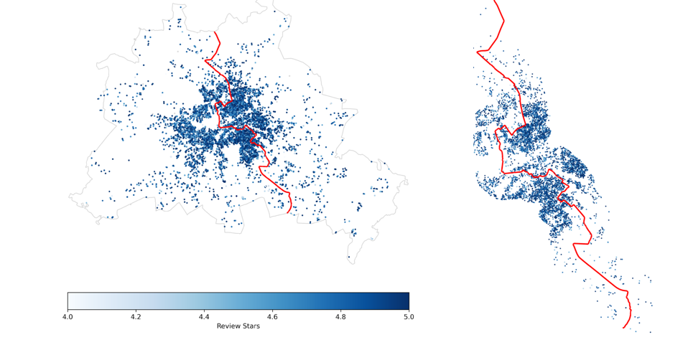

Text and Sentiment Analysis
Given the limited descriptive differences identified between East and West Berlin Airbnb listings, we proceed with a more nuanced examination using text and sentiment analyses. Specifically, leveraging the Inside Airbnb dataset, we conduct a descriptive analysis of three textual components: guest reviews, listed amenities, and host descriptions. Additionally, these analyses are performed with consideration of neighborhood-level variation, though no differences were identified and therefore neighborhood-level takeaways are not discussed further.
To prepare the data for analysis, all textual entries are standardized by converting them to lowercase, tokenizing by whitespace, and removing “stopwords” in both English and German, such as “the” or “if”.
Guest Reviews: Following a stay, Airbnb guests are encouraged to leave written reviews in addition to star reviews. These reviews are largely unstructured, with few restrictions on language or format. To explore possible textual differences between East and West Berlin, we ask: are there meaningful differences in the content of guest reviews across the former Berlin divide? This investigation supplements the previously reported analysis of star reviews.
Figure 6 presents a word cloud of the most frequently used words in guest reviews. Given, the identicalness of word occurrences between East and West Berlin, we removed generic housing-related terms (e.g., “apartment”, “place”, “location”, and “wohnung”—the German word for apartment, etc), as well as contextually uninformative terms such as “host” and “berlin.” This leaves the five most common words: great, nice, super, clean, and good. When disaggregating the data by East and West Berlin, we no meaningful difference in word frequencies between the two sides, as seen in Figure 6. The only notable difference in the top 10 lists is the appearance of “restaurants” in East Berlin and “comfortable” in West Berlin. All positively connoted words. These results are consistent with our earlier observation that the vast majority of star ratings are above 4.0, suggesting either uniformly positive guest experiences, or biased data.

Figure 6: Word Cloud for Top Words in Guest Reviews
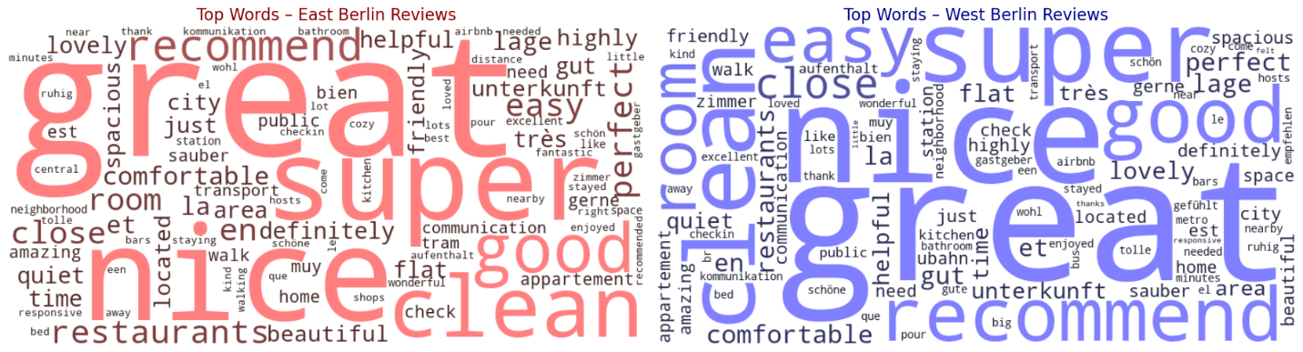

Beyond identifying word frequency, we employ sentiment analysis to assess the emotional tone of guest reviews. Sentiment scoring assigns a polarity value to each word, and the total score of a review reflects the reviews overall sentiment. A highly positive review approaches a sentiment score of 1, while a highly negative review approaches –1. For Berlin in total, the mean guest review sentiment score is 0.39, the median is 0.62. The median West Berlin sentiment score of 0.62 is slightly lower than the median East Berlin sentiment score of 0.69. Figure 7 illustrates how sentiment scores are distributed across listings locations, there is no clear pattern with relation to the division.
We also examine whether Airbnb sentiment differs by price. For both positive and negative reviews, the median nightly price of listings in East Berlin was $10 higher than in West Berlin. Within each side, the median price difference between listings with positive and negative sentiment was $5. These findings suggest that neither price nor division-side likely influences the emotional tone of guest reviews. Overall, we find no meaningful difference in sentiment scores between East and West Berlin, indicating that the city’s historical division may not play a discernible role in shaping guests’ experiences or perceptions.
Although, one interesting takeaway is that the five most negative reviews—on both sides of the former divide—were written in German, while the five most positive were written in English. While not directly related to East-West distinctions, this observation may reflect underlying cultural differences in expression or expectation. This presents an avenue for future inquiry, particularly if review language can be linked to Airbnb guest country of origin. Such a linkage would allow for comparative sentiment analysis between German and non-German tourists. Future research might expand on this analysis by examining sentiment differences across boroughs, by Airbnb size, listing tenure, or characteristics, however, this is out of the scope of our study at this time.
Figure 7: Airbnb Listings Colored by Sentiment Scores based on Reviews
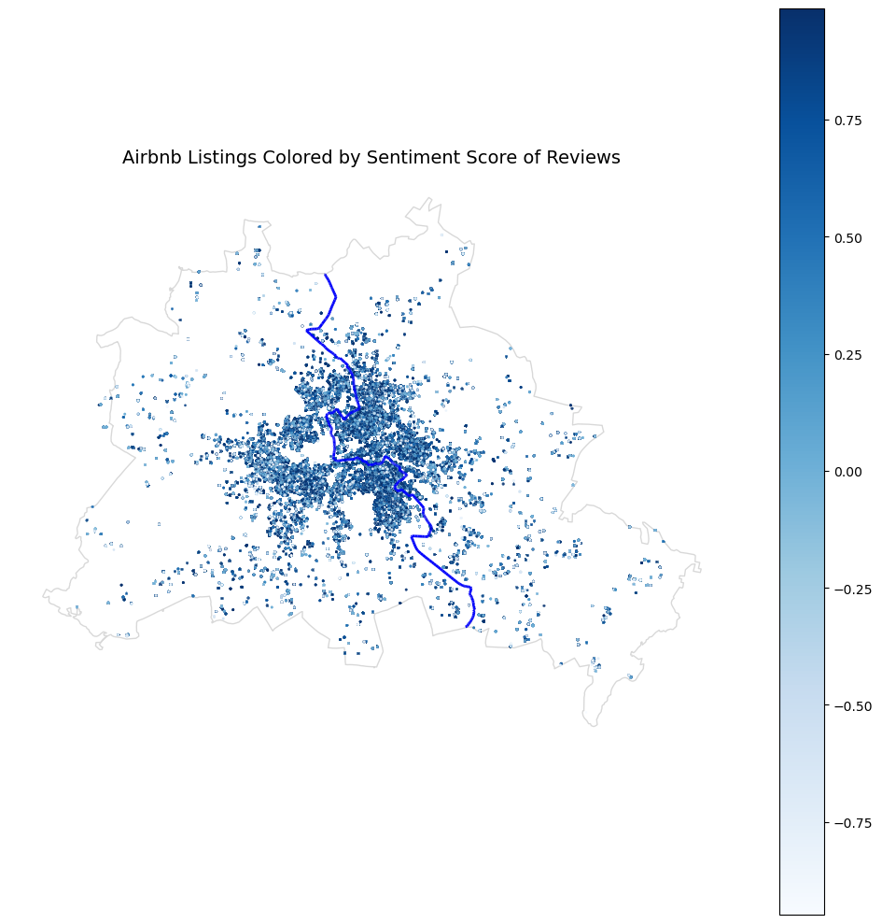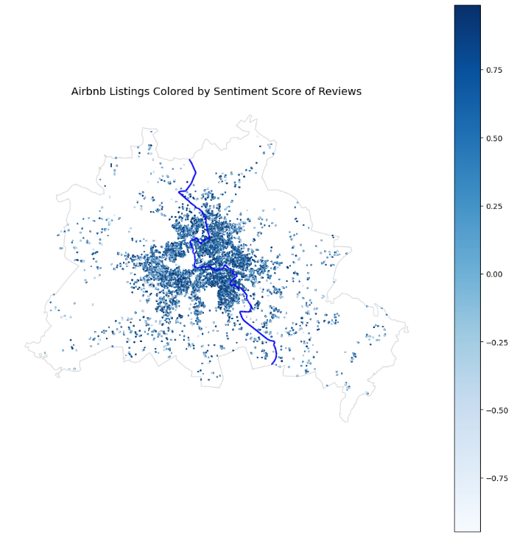

Amenity Descriptions: Amenities offered in Airbnb listings can influence guest decisions and may potentially reflect lingering spatial patterns rooted in the historical East–West division of Berlin. If this division shaped the housing market—through infrastructure, policy, or other channels—it could be reflected in the types or quantities of amenities provided. However, our analysis finds no significant difference in the ten most frequently listed amenities across the former divide. These include Wi-Fi, kitchen, heating, essentials, washer, dryer, hair dryer, alarm, smoke detector, and hot water. This similarity is unsurprising, given Berlin’s level of economic development and the fact that these amenities are normal goods.
We also explored the use of sentiment analysis on amenity listings but found it to be an unsuitable method in this context. By design, amenities are intended to convey positive features, yet the sentiment tool can misclassify them due to isolated word associations. For instance, an Airbnb listing that includes “fire extinguisher,” “kitchen,” “smoke,” “alarm,” “TV,” “washer,” and “Wi-Fi” as their amenities received a sentiment score of –0.59. This likely results from negative values assigned to words like “fire,” “extinguisher,” “alarm,” and “smoke,” despite these features potentially signaling safety and quality to guests. Therefore, we conclude that sentiment analysis does not reliably capture the intended meaning or guest perception of amenity listings.
Host Descriptions: If there remain meaningful sociodemographic differences between East and West Berlin—potentially as a legacy of the city's historical division—then such differences might manifest in the language used by hosts to describe their listings. This hypothesis assumes, however, that Airbnb hosts typically operate within a single geographic area and do not maintain listings on both sides of the former divide. Even under this assumption, our analysis reveals no meaningful differences in host description language between East and West Berlin.
As with amenity descriptions, we attempted a sentiment analysis of host descriptions to further investigate potential differences. However, we found that sentiment analysis tools did not perform reliably on this category of text. For example, the phrase: “Forget your worries in this spacious and quiet space” received a sentiment score of –0.57, erroneously implying a strongly negative sentiment. We attribute this misclassification to the sentiment analysis model's treatment of individual words such as “forget” and “worries”, which are weighted negatively in isolation. However, in context, the phrase clearly conveys a positive message. Due to this misalignment, we conclude that a sentiment analysis tool is not well-suited for evaluating Airbnb host-generated marketing language. As a result, we do not present further sentiment-based findings from host descriptions.
Similar to our descriptive analysis, the preliminary text and sentiment analyses finds no meaningful difference in the Airbnb market of East and West Berlin.

Conclusion
This study preliminarily examines the characteristics of Airbnb listings in East and West Berlin using data from the December 2024 release of Inside Airbnb. Despite the city’s historical division, our analysis reveals substantial similarities across both regions in terms of Airbnb attributes. Prices per night, average review ratings, room type distributions, and licensure rates show no significant differences between East and West Berlin. Even by applying a within 2-kilometer buffer of the former Berlin Wall, listing characteristics remain comparable within and outside of the 2-kilometer. Sentiment analysis of guest reviews also shows no meaningful divergence in tone or content across the two sides.
Interestingly, this convergence occurs despite ongoing household differences in East and West Germany still persisting from the former Berlin Wall (Ahfeldt et al (2015); Burchardi and Hassan (2011); Kottasova and Croker (2019)). Thus, the extreme degree of similarity between East and West Berlin Airbnb market given the division, is at minimal, interesting. Overall, the results indicate that the effect of the Berlin Wall on the Airbnb market has faded or never persisted.

References
Ahlfeldt, G. M., Redding, S. J., Sturm, D. M., & Wolf, N. (2015). The economics of density: Evidence from the Berlin Wall. Econometrica, 83(6), 2127–2189.
Burchardi, K. B., & Hassan, T. A. (2013). The economic impact of social ties: Evidence from German reunification. The Quarterly Journal of Economics, 128(3), 1219–1271. https://www.jstor.org/stable/26372522
Inside Airbnb. (n.d.). Data downloads. https://insideairbnb.com/
Kottasova, I., & Croker, N. (2019, November 7). The Berlin Wall fell 30 years ago. But an invisible barrier still divides Germany. CNN. https://www.cnn.com/2019/11/07/europe/berlin-wall-fall-30th-anniversary-intl-grm

